NOMINATED HOTELS FOR THE BSIR AGM & CONFERENCE BIRMINGHAM 2017

Accommodation available Tuesday 31st October – Thursday 2nd November 2017 inclusive (ADDITIONAL NIGHTS AVAILABLE)

To make an accommodation reservation, please email jules@venuefinder.net or call on 015242 76141. Jules will require your contact details, number of nights you require, type of accommodation (double room for sole occupancy, twin room), hotel choice and a credit card number to use as a guarantee against your room.

NOVOTEL BIRMINGHAM 15 rooms available

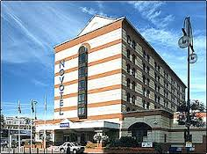

- 4 star hotel on Broad Street, close to bars and restaurants
- 8 minute walk to ICC
- 148 bedrooms, including free Wi Fi
- Gym and sauna
- On site parking (chargeable)
- 31st October - £129 BB
- 1st November - £139 BB
- 2nd November - £99 BB
- Twin supplement is £10 per room per night. Twin rooms use sofa bed as their second bed.
- Rates include VAT
- 1 mile from New Street Station. 15 minutes walk.

HILTON GARDEN INN 25 Rooms Available

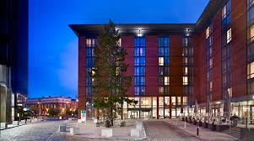

- Located in Birmingham’s prestigious Brindleyplace Development
- One of the closest hotels to the I.C.C Conference Centre
- Complimentary WiFi throughout the hotel
- City Café serving international cuisine and Pavilion Pantry stocking travel essentials
- Two outdoor terraces – perfect for drinks, nibbles, and meals
- Complimentary fitness centre
- Q-Park, Brindleyplace is the hotels preferred parking partner within a short walking distance. Users of the hotel can receive a 10% discount off their parking when validating their ticket at the hotel reception. For more details or to pre-book your parking click on this link http://www.q-park.co.uk/parking/birmingham. Currently £15 per day
- New Street Station is 1 mile away, 5 minutes in a taxi and 15 minutes walk
- Rate: £139 BB sole occupancy and £149 BB twin occupancy
- Rates include VAT

HAMPTON BY HILTON 40 rooms available
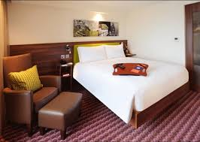

- Located on Broad Street – good 3 star standard
- One of the closest hotels to the I.C.C Conference Centre – 5 minutes walk
- Complimentary WiFi throughout the hotel
- On site car parking for 90 cars – (currently £13.50 per night)
- 1 mile from New Street Station – 5 mins taxi, 15 minutes walk
- Stop by the Gathering Zone, which offers an assortment of light meals and snacks 24-hours a day. The hotel’s location on the key bar and restaurant street in Birmingham makes it easy to find something for everyone’s taste.
- Fitness Centre
- £135 BB sole occupancy/ £145 BB twin occupancy
- Rates include VAT

PARK REGIS HOTEL 20 rooms available
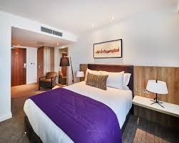
- 4 star hotel with 253 bedrooms
- 12 minutes walk from the ICC
- Spa and Gym
- Free WiFi
- On site car parking at £10 per 24 hours (ask at reception)
- £125 BB for sole occupancy rooms including VAT

JURYS INN BIRMIGHAM 30 rooms available
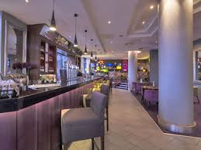
- Located on Broad Street
- 6 minutes walk to ICC
- 1 mile from New Street Station – 5 mins taxi, 15 minutes walk
- Free WiFi
- Alongside an open kitchen and chic booths for private dining, the stylish new restaurant and bar, ‘The Grill on Broad Street’, offers a delicious and a varied menu from small plates and ‘Home Comforts’ to juicy steak and burgers from the grill.
- All Day Costa Coffee area
- Rates: £130 sole occupancy / £140 BB twin occupancy
- Rates include VAT
IBIS STYLES BIRMINGHAM 10 ROOMS AVAILABLE
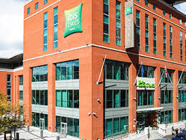

- 10 minute walk to the ICC (0.5 mile via Fleet St)
- 1 mile from New Street Station, 5 mins taxi
- Free WiFi
- Bar open until 2am
- No Restaurant
- Rate: £115 Bed and Continental Breakfast
- Car Parking: Chargeable at £13.00 per 24 hours

