NOMINATED HOTELS FOR BSIR
BOURNEMOUTH 2018
ACCOMMODATION DATES ARE TUESDAY 13TH NOVEMBER X 3 NIGHTS

Bournemouth Highcliff Marriott

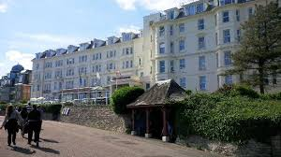

- 5 minutes’ walk to the Bournemouth International Conference Centre
- Leisure Club including indoor pool
- 4 Star hotel
- Restaurant and bar
- 160 bedrooms, some with sea view
- Hi speed internet (chargeable)
- Parking on site (chargeable)
- Rates: £170 BB for room for sole use per night

HILTON BOURNEMOUTH

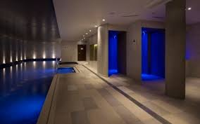
- 8 minute walk to the conference centre
- 4 star hotel
- LEVEL8IGHT The Sky Bar with panoramic views over Bournemouth
- Modern British cuisine at Schpoons & Forx, led by restaurateur and TV personality Chef Matt Tebbutt
- eforea spa and health club with indoor heated pool, treatments rooms, steam and sauna
- Free Wi Fi
- Small car park next door (chargeable)
- £175 BB for sole use per night

HAMPTON BY HILTON BOURNEMOUTH

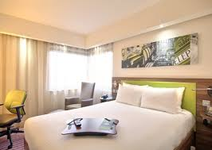

- 5 minutes’ walk to the Conference Centre
- Complimentary Wi Fi
- Gym/ Fitness Centre
- 3 star rating but 4 star standard
- Parking on site (chargeable)
- Rates: £130 BB for room for sole use per night
BEST WESTERN ROYALE HOTEL BOURNEMOUTH

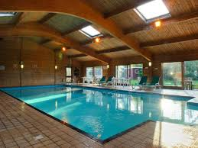

- 64 bedrooms in total
- Indoor pool, sauna
- 10 minute walk to the Conference Centre
- Free internet
- Chargeable car parking
- Check in 1500 and check out 1100
- Single Bedded room £69 B&B per night
- Double bed for sole use £79 B&B per night
- Restaurant and bar

RAMADA ENCORE BOURNEMOUTH

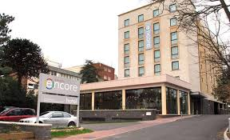

- 112 bedrooms
- Free internet
- Chargeable parking
- 15 minute walk to the conference centre
- Check in 1500 and check out 1100
- Restaurant and bar
- Double for sole use £89 B&B per night
ORCHID HOTEL

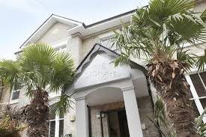

- Recently refurbished hotel
- 32 bedrooms
- 10 minutes walk to the conference centre
- Free WiFi
- Chargeable car parking
- Restaurant and bar
- Double for sole use £100 B&B per night

THE CUMBERLAND HOTEL

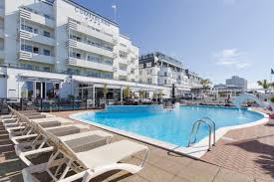

- 4 star hotel with 107 bedrooms
- 15 minute walk to the conference centre
- Free WiFi
- Free parking
- Shared leisure facilities including indoor pool
- Art Deco style
- Restaurant and bar

- Double for sole use £95 BB per night
THE GREEN HOUSE HOTEL

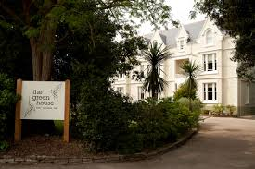

- One of the worlds top Eco hotels
- 32 bedrooms
- 10 minute walk from the Conference Centre
- £108 for a double for sole use per night
- Parking chargeable
- Free WiFi

PARK CENTRAL HOTEL SOLD OUT

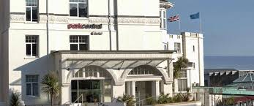

- Free Wi Fi
- Crab & Fish restaurant
- Park Central Hotel has limited car parking spaces which are located for patrons on the 3rd floor of the B.I.C car park, just a minute’s walk from the hotel entrance. Car parking is chargeable at £11.00 per day and must be reserved prior to arrival.
- 6 standard rooms at £85 BB for sole use per night
- 4 executive rooms at £115 BB for sole use per night

Please email me jules@venuefinder.net with your choice of hotel, number of rooms, arrival date and number of nights and I will make a booking for you!

Many thanks

Jules Natlacen
Discovery Conferences
Barbon
LA6 2LL
Tel 015242 76141
Mobile 07966 336789

