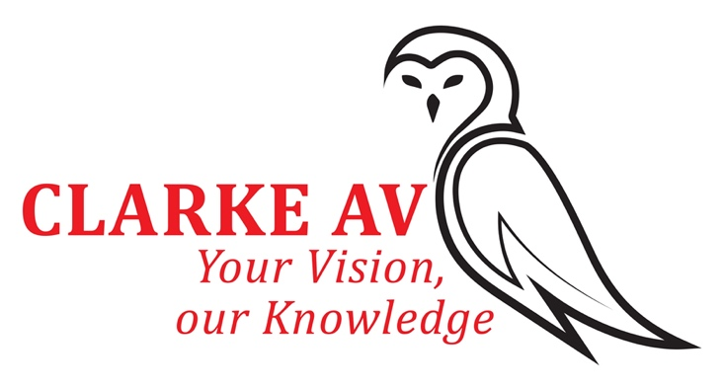
Clarke AV Ltd
7 Palfrey Road
Bournemouth
Dorset
BH10 6DL
Tel: 07739021203
Email scott@clarkeav.co.uk
www.clarkeav.co.uk

Please read below important information regarding your presentation. I realise that many of you have participated in the online webinar programmes and live events but please familiarise yourself with the information and prerecording instructions for IOUK2022. (IOUK will use the vMix streaming platform to connect you to the conference and have dedicated AV assistance throughout).
- Ensure all PowerPoint is 16:9 Ratio, 4:3 will no longer be supported. 16:9 fills modern widescreen monitors!
- Please arrange a Tech test with Scott Clarke, our AV manager ASAP - (this will check your device connectivity and assist with the prerecording).
- Scott (scott@clarkeav.co.uk) is copied into this email and his details are below.
- All presentations will be pre-recorded using the BSIR recording system and uploaded on to vMix system for playback during conference.
- Your presentation on the day of your session will be played and you will have the opportunity to log in before the session starts, speak to the other presenters and join them and the audience for live questions and answers. You will have a presence throughout the session to the audience.
- Discussions/Q and A sessions can be live.
- Once recorded the presentation can be finalised / edited by Scott Clarke scott@clarkeav.co.uk. This does take time so please ensure completed by deadline Monday 23rd May 2022
- vMix streaming platform is browser based and you will need updated Chrome (or Firefox) along with Windows 10 or up to date MAC OS Please do not try to present on phones or tablets or other browsers, this WILL cause issues!
- If you need help, please let either me or Scott know. We are here to help!
- Please make time on the day to ensure all computer updates have been completed and no other programmes are running in background – e.g., Zoom, skype etc.!! Microsoft, Google Chrome etc. have a habit of releasing and forcing updates at the most in opportune moments!!
- Scott will be in contact to arrange tech test and assist with prerecording, Please DO NOT ignore these requests to arrange tests, these tests help to ensure the meeting goes as smoothly as possible for you.
- Instructions to join on the day of the event will be sent nearer the time.
- Please check spam account if you do not receive the presenter link or call Scott (scott@clarkeav.co.uk (+44 1202 352973 or mobile +44 7739021203)
- On the day of the meeting please Log On Early (Times will be advised during tests) before your session to iron out any issues.
I will be in touch separately for headshots and bios.
If you have any queries, then please contact me Ruth Moss – details below.
Many thanks again for your participation.
BSIR MEETING OFFICE

