BSIR R&A Committee Registries Policy Document

Purpose:
Registry data have played an important part in the development of interventional radiology techniques and in the documentation of safety. They have sometimes changed practice (eg. the identification of high rates of morbidity in patients undergoing emergency biliary procedures). They are extremely useful tools in areas of practice where other forms of investigation would be impractical or prohibitively expensive. The BSIR is firmly committed to supporting high quality research and innovation in interventional radiology.

Perhaps inevitably where individuals are busy and have other calls on their time, the data provided by voluntary registries are sometimes undermined by suboptimal or selective data entry, variable ascertainment over time and lack of follow up data. The BSIR hopes that good up-front registry design will mitigate some of these factors and result in improvements in data collection and completeness and therefore the quality and robustness of any interpretation of these data.

This document makes recommendations about key areas of good registry design and implementation which may assist in registry development. These recommendations are largely based on the IDEAL framework ( http://www.ideal-collaboration.net/ ) [1-3], originally published to support single arm trials and registries in surgical specialties but equally applicable to interventional radiology. Many aspects of this framework have been used in the development of this policy document.

The BSIR R&A committee will consider applications for new registries in the light of the recommendations in this document. A registry proposal form is included which will provide prospective applicants with a structure to inform their application. The R&A committee is happy to offer support and advice in the development of new registries.

Ideal framework study categories [1-3]:

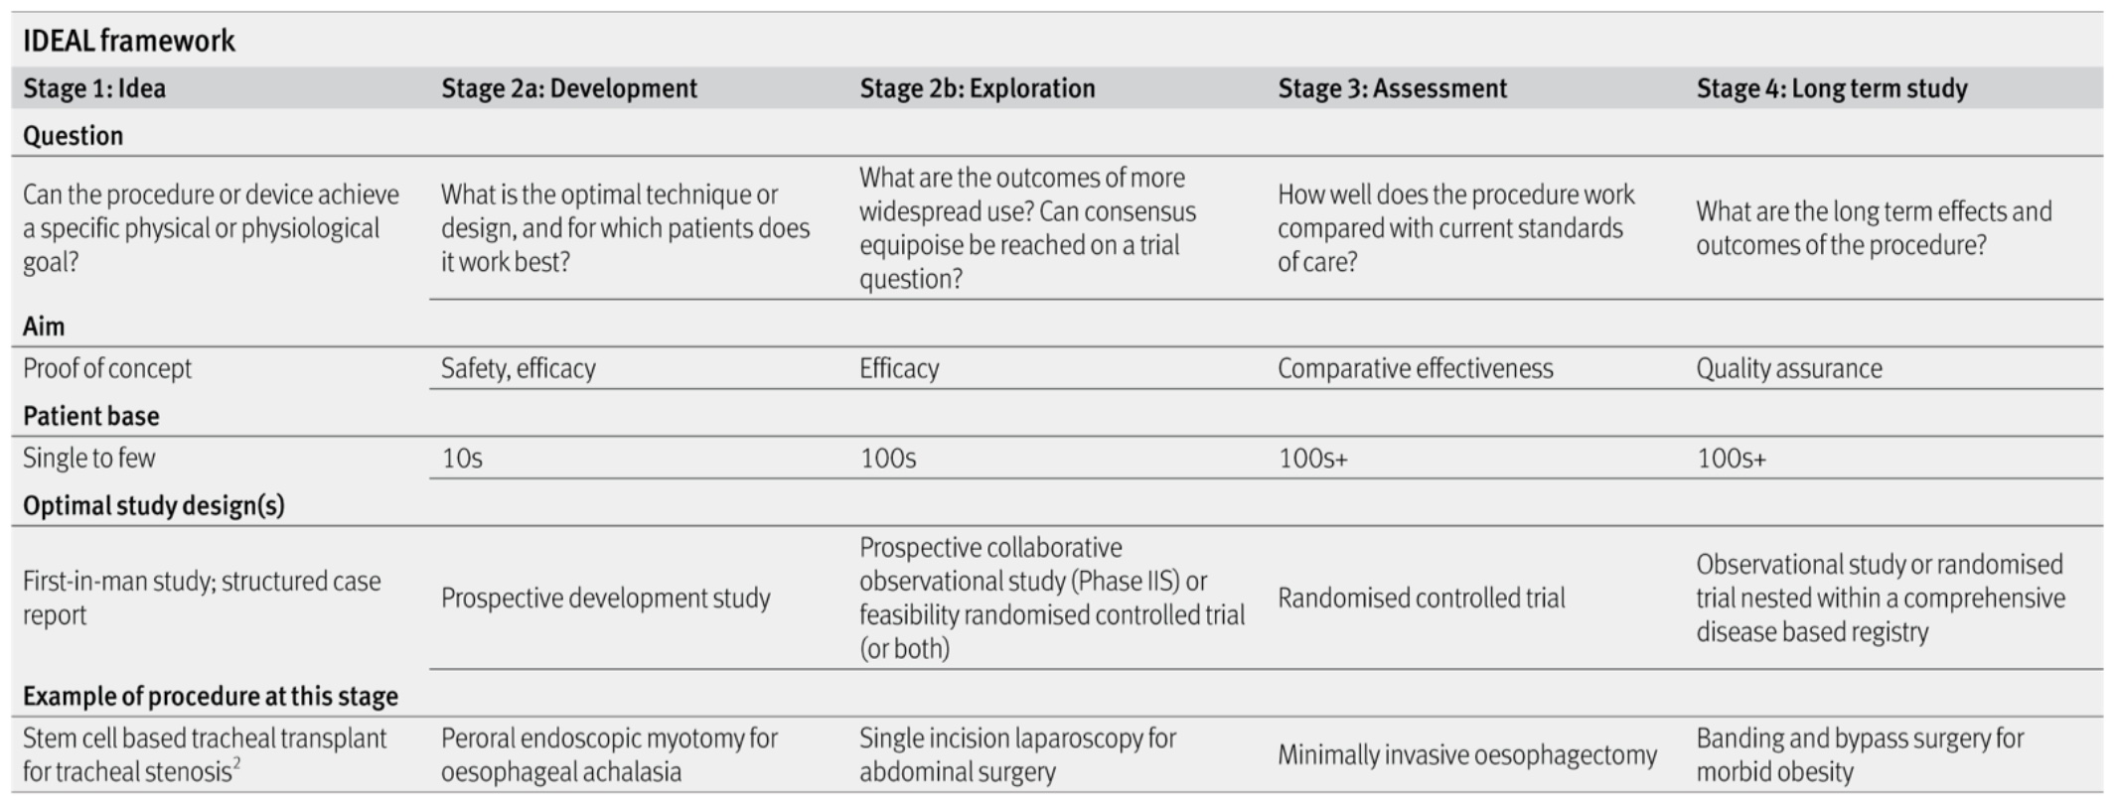

Registry ownership
There should be a defined person (or people) who will remain responsible (via the R&A committee) for the coordination of registry activity including data analysis, the assessment of ascertainment rates, report writing, engagement with BSIR membership to promote registry data entry etc. This would normally be the person proposing the registry. Registry coordinators may be co-opted onto the R&A committee for the duration of the registry.

Registry purpose
Registries should have a stated purpose with a clearly defined research or safety question of interest. It is anticipated that most future BSIR registries will reflect stage 2a (development) or 2b (exploration) stages of the IDEAL framework

Registry design
Registry design should incorporate all or most of the aspects of best practice as identified in the IDEAL framework. It should have a published protocol prior to inception which should include:

Background:
- Brief summary of relevant literature including areas of uncertainty which the registry is designed to address. Indication of whether the registry is designed to be exploratory research (eg. like the ROPE or SIRT registries) or benchmarking of safety and outcomes of established practice.
- There should be a summary of relevant calls for evidence from national bodies (eg. NICE, NHSE) if these are available.

Clinical features:
- A diagnosis rather than a procedure based eligibility is preferred as this will also collect data on patients not treated with the procedure of interest (for example a registry of all patients presenting to a unit with ruptured AAA, not just those treated with EVAR). It is accepted that this may not always be possible, especially in diagnoses where only a small number of patients may be treated with IR.
- Clear inclusion criteria with sequential reporting of all consecutive eligible cases with no inclusion bias.
- Definition of baseline individual patient characteristics relevant to outcome of interest.
- Clear description of the intervention in question including technical procedural detail where appropriate.
- Standardised definitions of the objective outcomes of interest.
- Standardised definitions of harms (eg. Dindo-Clavien system).

Organisational features:
- Number of collaborating units or organisations (planned or actual). Is this to be a national registry, regional or local?
If more than one centre is to be involved, it would be preferred to have joint applications from IRs from each (or at least more than one) centre.
- Number of collaborating clinicians within each unit.
- Involvement of clinical colleagues in relevant other specialties in registry design and day-to-day running eg. patient enrolment and consent (examples might be general medicine or haematology in a registry of ilio-femoral DVT catheter directed thrombolysis).
It would be preferred to have non-IR colleagues as co-applicants if there is significant non-IR input.
- Overall registry timescale with inception and closure dates for new entrants and for follow up. Will this be time dependent (ie. clear opening and closing dates) or dependent on numbers recruited (ie. only closing when a certain number of patients have been entered)
- What epidemiological analyses have been done. Has a clinical epidemiologist been involved?

Resource features:
- Likely resource implications of running the registry (staffing, IT, time) especially of the registry proposer.
- How will advertising and marketing of the registry (including ongoing encouragement of data entry) be undertaken?
- Funding sources established already. Are these from industry or independent bodies?
- Potential future funding sources. Will this need ‘pump-priming’ funding only or a longer-term commitment.
- Are external bodies or non-clinical colleagues involved (eg. other professional organisations, university departmental input).

Role of the BSIR in registry design and running
The BSIR had insufficient resource to solely fund large scale registry projects of the types identified in the IDEAL framework, particularly stage 2b projects. However, the society can assist with funding and support for initial registry design and piloting (pump-priming) and assist with the development of links to other potential sponsors (eg. NIHR, industry), and to epidemiological and statistical expertise and expertise in Health Technology Assessment.

The BSIR will consider applications for funding of registries in a similar way to the current processes for funding educational and research grants. Additionally, the BSIR can assist in promoting and disseminating information about registries via its membership.

Dr Christopher Hammond
ex BSIR R&A Chair
12.11.2017

BSIR Registry Proposal form

Registry name

Proposers
Primary proposer:

Contact details: email address:
Phone number:
Address:

Second proposer:

Contact details: email address:
Phone number:
Address:

Registry type: Exploratory / research ☐
Benchmarking and safety ☐
Other ☐

Background
Please include details of why this is registry needed and the clinical question to be addressed. What is already known about this subject and what is it hoped the registry will add? Are there any national calls for evidence (eg. NICE, NIHR) on this subject?

Max 500 words

Proposed registry design
Please include details of: inclusion and exclusion criteria, baseline data and technical and procedural details, complications and outcome measures of interest and details of follow up.
Is there to be a comparator group (randomisation is not expected)?
How many patients will be recruited or for how long will the registry recruit?

Max 500 words

Organisational features
Please include details of planned number or participating clinicians and / or centres. Will non-IR clinicians or nursing staff be involved? Are other organisations involved? How will follow up be organised?

Max 500 words

Resources needed
Include details of likely resource requirements (time, money, personnel). What other sources of funding have been explored? Is a proof-of-concept or pump-priming grant required or are there likely to be significant on-costs. Is BSIR sponsorship needed to aid in linking to other sources of funding?

Max 500 words

Any other information to support this application?

Max 500 words

Signatures
Proposer: Seconder:

Date: Date:

References

- IDEAL framework for surgical innovation 1: the idea and development stages. McCulloch P, Cook JA, Altman DG, Heneghan C, Diener MK on behalf of the IDEAL group. BMJ 2013; 346: f3012

- IDEAL framework for surgical innovation 2: observational studies in the exploration and assessment stages. Ergina PL, Barkun JS, McCulloch P, Cook JA, Altman DG on behalf of the IDEAL group. BMJ 2013; 346: f3011

- IDEAL framework for surgical innovation 3: randomised controlled trials in the assessment stage and evaluations in the long term study stage. Cook JA, McCulloch P, Blazeby JM, Beard DJ, Marinac-Dabic D, Sedrakyan A on behalf of the IDEAL group. BMJ 2013;346:f2820

