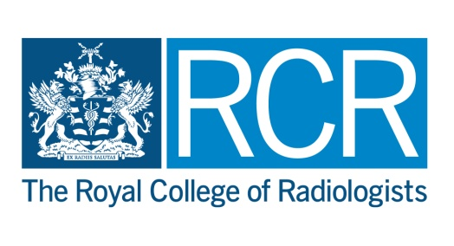

RCR and the British Society of Interventional Radiology (BSIR) Graham Plant Professorship 2017

Applications are invited for a visiting professorship, jointly funded by the RCR and BSIR in memory of Dr Graham Plant, a founder of the BSIR who was an was enthusiastic teacher and supporter of education for Interventional Radiology. The professorship is open to interventional radiologists who are Fellows of the RCR in good standing, members of the BSIR, resident in the United Kingdom and in active clinical practice at the time of the application and the award/visit.

The visiting professor will be expected to undertake 6-8 visits to training programmes, over a period of 12 months, to deliver lectures and undertake appropriate workshops or small group teaching as part of each visit. One lecture will be filmed and made available online. The purpose of the visits is educational: to highlight the role of IR in improving patient care and academic IR in the development of advanced imaging and procedural techniques, along with providing IR teaching at both trainee and consultant level at centres that might otherwise not have access to advanced subspecialty techniques or the field of interest of the successful candidate.

At the end of the professorship, the successful candidate will be required to render a report and deliver a lecture at the next BSIR annual meeting.

Applications should comprise
    - A current curriculum vitae
    - A 200 - 400 word description of the applicant’s teaching record and a description of why they would be suitable for the professorship
    - A list of proposed workshop/lecture titles suitable for presentation to the training programmes

Application and Assessment Procedure
- Applications should be sent to Sarah Coulson QATraining@rcr.ac.uk at the Royal College of Radiologists to arrive not later than Friday 21 April 2017.
- An Appointments Board combined of members of the Royal College of Radiologists and the British Society of Interventional Radiology will consider applications. The decision of the Appointments Board is final and binding.
- Applicants will be informed of the outcome of their applications as soon as possible after the decision has been approved.

