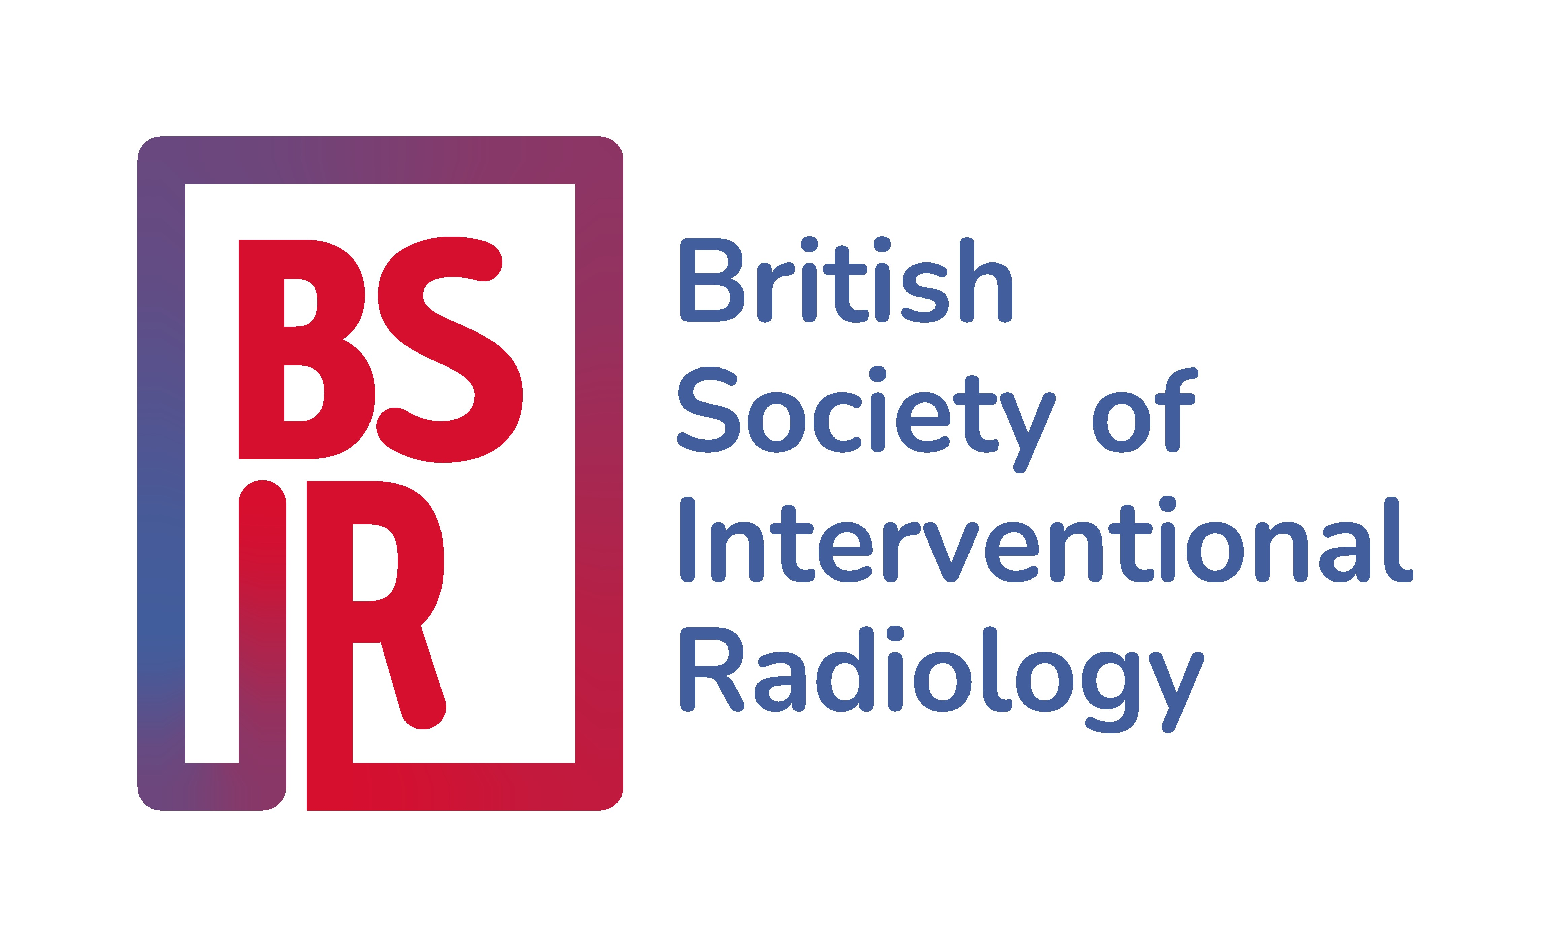

BSIR Educational Bursary 2025
Application Form

Closing date: 23 May 2025

Please complete in font size 10

Name

Hospital

Address for Correspondence
Email address

Telephone

Grade / year of training or year of consultant appointment
Amount of funding required

- Please provide details, as precisely as possible, of the educational activity for which you require support from BSIR. (max. 150 words)

(eg. What is it? Is it a course, a structured training programme or one to one ad hoc teaching? Is it classroom learning or “hands on”? How many cases might you expect to see etc.)

- Please provide a detailed breakdown of the funding requested.

- Why do you need support from BSIR? Please indicate any other sources of funding available to you. (max. 150 words)

- What benefits will the support bring to you, your organisation, patients, the wider NHS and BSIR? (max. 150 words)

- Please provide details of the Hospital Account in to which funds can be deposited
BACS Payment Details

Bank Name: |  | Account Name:
Sort Code: |  | Account Number:

I confirm that the above statement is true to the best of my knowledge and that I am an active member of the BSIR.

Date

Signature

Please email as a PDF to julie.ellison@bsir.org

by 23 May 2025

