NOMINATED HOTELS FOR APC HULL
THE COURSE RUNS 20 AND 21ST JUNE 2018
VENUE FOR APC IS HULL ROYAL INFIRMARY
Please contact Jules Natlacen on 015242 76141 or jules@venuefinder.net to make a booking. Thank you.

HOLIDAY INN HULL MARINA
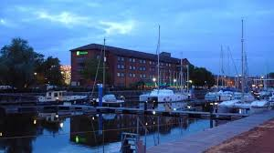
- 20 – 25 minutes walk to the Hull Royal Infirmary
- 5 minutes walk to Hull City Centre
- Health Club including indoor pool
- Parking is charged at £7 per day
- Check in is from 2pm and check out by 12 noon
- Rate is £101 BB
- Rates include Breakfast and VAT

IBIS HOTEL HULL
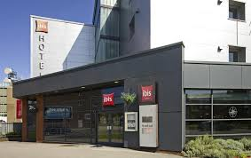

- 106 bedrooms
- 0.8 miles from Hull Royal Infirmary – 15 minutes
- Free Wi Fi
- Chargeable parking nearby
- £60 BB for sole use or £65 BB twin use

DOUBLETREE BY HILTON HULL
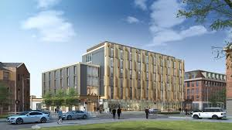
- Newly opened Hotel (late 2017)
- 1 mile from Hull Royal Infirmary – 20 minutes walk
- Located in the City Centre
- Steakhouse, lobby lounge, rooftop bar and 24-hour room service
- Fitness Centre
- Parking is £10 per 24 hours
- £109 BB for sole occupancy and £119 BB for twin occupancy

THE CHURCHMOUSE AT BARBON, BARBON, CUMBRIA LA6 2LL
TEL 015242 76141 EMAIL : info@venuefinder.net
MOB 07966 336789 CONTACT: JULES NATLACEN

