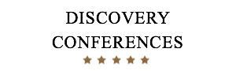

NOMINATED HOTELS FOR IOUK 16 AND 17 MAY 2018
VENUE FOR IOUK IS INTERNATIONAL CENTRE FOR LIFE
Please contact Jules Natlacen on 015242 76141 or jules@venuefinder.net to make a booking. Thank you.

JURYS INN NEWCASTLE
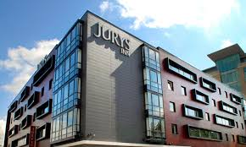
- 4 minute walk to the International Centre for Life
- 8 minute walk from Newcastle Central Station
- 274 bedroom hotel
- Free WiFi
- Costa Coffee Bar, restaurant and bar
- Check in is 2 pm and check out 12 noon
- Off site car parking – Times Square NCP which is a 2 minute walk away from the hotel. Prices are £1 per hour or £8.50 for 24 hours.
- Arena Square Car Park - £7.50 for 24 hours - 3 minutes walk from the hotel.
- Weekly permit available from the car park office on level 1 - £24 Mon - Fri, £30 Mon – Sun
- Rates: £119 BB for sole use and £129 BB for twin/double use
- Rates include Breakfast and VAT

HAMPTON BY HILTON NEWCASTLE
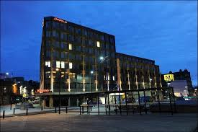

- Located opposite the train station
- 7 minutes walk to the International Centre for Life
- Parking at the train station or Centre for Life
- Check in 3pm and check out 12 noon
- Business Centre and Gym
- Free Wi Fi
- £90 BB for sole occupancy
- Rates include Breakfast and VAT

THE COUNTY HOTEL NEWCASTLE
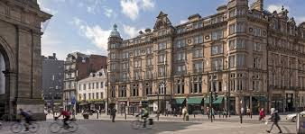
- 5 Minutes walk from the Centre for Life
- Opposite the train station
- Parking is limited at the hotel – just 10 spaces or you can park at the station
- Check in time 3pm and check out 11 am
- Free Wi Fi
- £80 BB for sole use and £90 BB for twin use
- Rates include Breakfast and VAT

THE CHURCHMOUSE AT BARBON, BARBON, CUMBRIA LA6 2LL
TEL 015242 76141 EMAIL : info@venuefinder.net
MOB 07966 336789 CONTACT: JULES NATLACEN

