HOTEL FOR BSIR IOUK ANNUAL MEETING
ACCOMMODATION AVAILABLE
MONDAY 18TH AND TUESDAY 19TH MAY 2020
(The meeting takes place on 19th and 20th May at Christies Hospital)

DIDSBURY HOUSE HOTEL, DIDSBURY, MANCHESTER

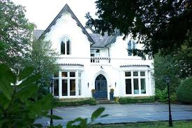

- This luxury Victorian townhouse is located 1.3 miles from Christies Hospital
- 7 minute taxi ride (approx. £8)
- 27 bedrooms in total (we have most of the bedrooms allocated for us)
- Rate is £125 including breakfast + VAT = £150 per night
- Resident bar, lounge and walled terrace
- Walking distance to pubs and restaurants
- Free car parking on site
- So Spa – please contact Vicky Clayton on 07795 248969 to book an appointment
- Breakfast is served from 0700 – 1030
- Deli Menu is served in the Bar and Lounge from 1000 – 2200
- Check in is 1500 and check out is 1100
- Cancellation is free up to 12 noon on Monday 6th April 2020
- Please contact Jules Natlacen to book on 07966 336789 or email jules@venuefinder.net

